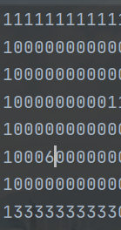ADDING NEW OBJECTS

1. Add a new symbol to the map file

Its 6 here

1. Decide if the object will be transparent or not

And proceed accordingly.

‘’’’

!If your image is transparent black color will be seethru. !Other colors not working currently.

‘’’’

Go to ray_cast.py/Rays class/__init__

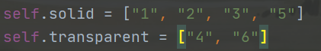Add it to the group where it belong, were sorting 6 here

1. In pygame_engine add it to the ray_dictionary function



Note: u might see second argument colorkey the thing is it isnt working idk why

If u dont want texture but just color just ask me or take example from “3” if its still there

At this point itll look like this with no collisions.

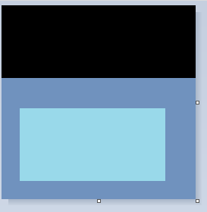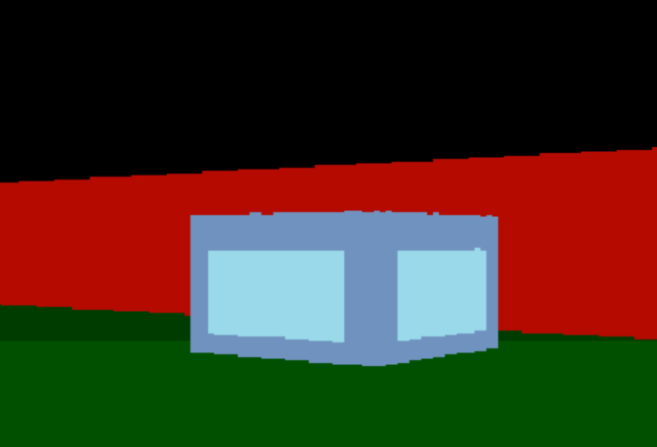

1. In load_objects we add new elif statement for new type of object or use already existing one

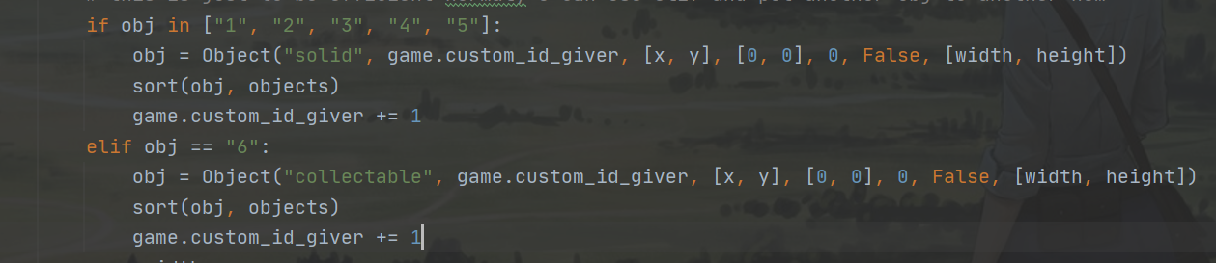

In Object()

We pass [type_of_object,

id(used when deleting),

Cords, movement, direction,

if it even is moving obj,

size]

Type is “collectable in our case”

1. Next we move to collisions class

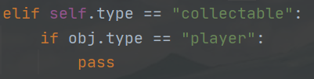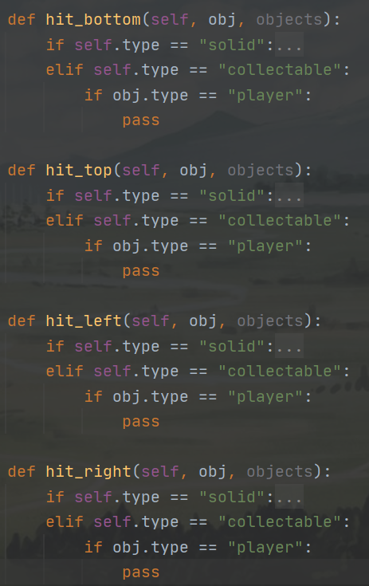

Self.type is obj that smt. collided

with.

And obj.type is object that collided, in our case the player

object.

We add path to this collision to

everywhere we want to.

1. In case of collectable we want to save the value that we collected smt.

Thats why objects class is also passed it has dictionary

Self.values where we can get values from.

(we also have object that collided, here it is Player so we can edit that object and also the other one, which is the collectable (objects have list in them self.memory so we can also use that on player because we have acces to player obj in the whole game loop))

Thus i add to attribute water here

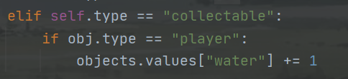

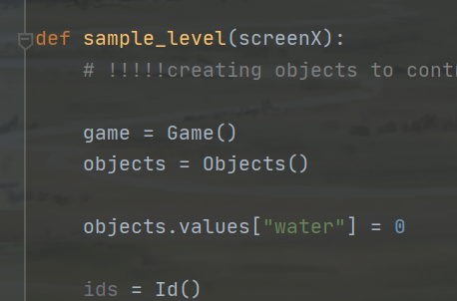

Also we add water attribute to objects.values when declaring objects.

1. And lastly we want to delete the object

I made all funcs do delete positions and objects while writing this so update engine pls. Also added some commands to sample.py so update that as well.

First we use this to find its possition in map file.



hit_pos = [int(self.object_pos[1] // 32), int(self.object_pos[0] // 32)]

And then add it to

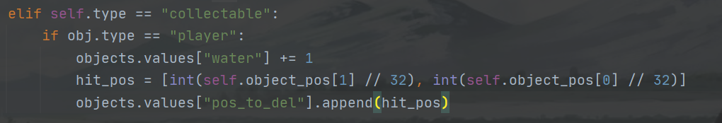

Now once we collide we wont see it again but collision will still be detected. To fix that.

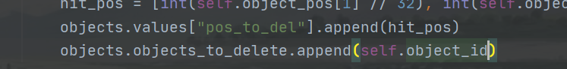

Dont forget to copy everything to every collision func u want to have it in. (hit_top, hit_bottom....)

And were done.

1. If u want ANIMATIONS contact me on dicord and ill do them they are pretty complex

Ps:

U can also try the water collectable, its in the engine on git

And there seems to be some new system to do images ask bung about it its very simple tho ill not write it here

ONE LAST FIX I FORGOT ABOUT

When player collides it can be on moltiple sides.

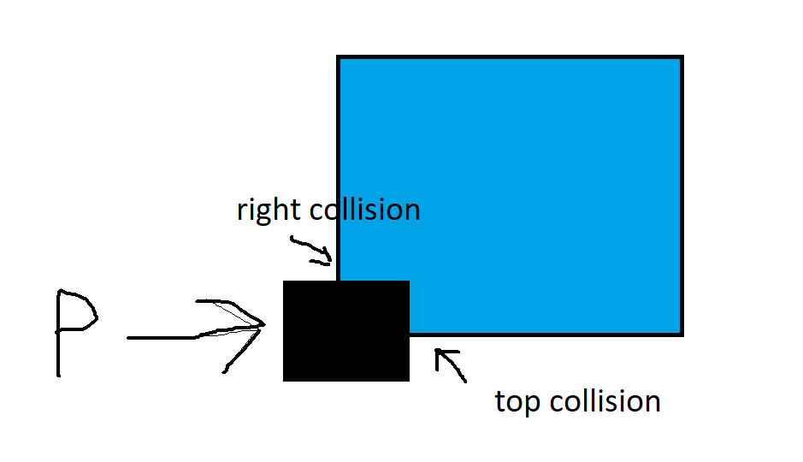

Because we use

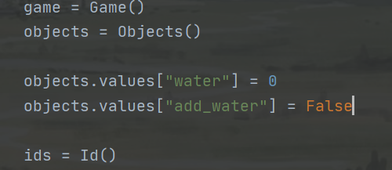It can happen that it adds water by 2 so we do the following to fix

1. we create new attribute

object.values[“add_water”]



1. Replace

With

1. 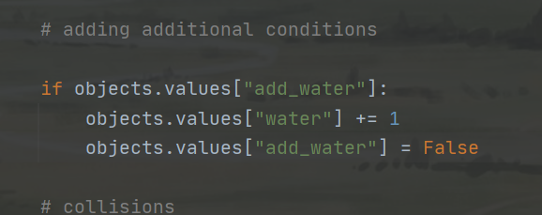Add the next code to game loop what it does u can figure by urself

Just dont put multiple waters together now cause the opposite will happen!